**Response to FPA's Proposal**

*By the Workers‘ United Front*

*Consisting of Labour Party, Communist Party of Patrium, The Fifth Position Party, The Peoples‘ Liberation Party and New Jacobin Club*

We, the people of the coallition Workers' United Front online at the time, have held a council consensus debate and stated our opinions about the Free Patrian Alliance Party Proposal and present our opinions written in a rather simple manner below.

I, **@Revlise, the transcriber of this debate promise, that I did everything in my power to ensure that the debate participants‘ opinions are present in in the following text, and proclaim that I endeavoured to make the messages of each participant in the debate voiced as much appropriately as possible and apologise for my fails.**

1. To the first point, we agree with the FPA that to ensure the military will not fall under unitary control and will not become too influential as a force of oppression, we should decentralize the power structure. We support the point of having a Council of National Defense rather than a single leader of the Armed Forces. However, we also propose introducing decentralization into each branch of the military as well, as a targeted effort to combat such potentially dangerous scenarios. It is proven that decentralized militaries are more effective in many ways, including keeping secrets from any enemies, making faster decisions, and inspiring loyalty from its troops. This would also decrease our budget spent on bureaucratic measures, which we could instead spend on the weapons and training necessary to protect our military.

2. For the second point, we are reluctant to enter into any binding military alliances with other countries. We cannot guarantee that they will not betray and backstab us and that it will be beneficial to us. We also cannot support allowing other countries to build bases on the soil of Patrium. Allowing foreign military bases would not be good for Patrium, as it could also pull us into wars in which we do not want to fight. In that case, we would not be neutral nation in the hypothetical war and the nations with bases in Patrium would hold significant control over our image, reputation and most importantly the lives of our people. Getting arms and ammunition in exchange for such dangerous situation would not be the positive choice. However, we are open to agreements with out countries, including providing support and weapon trade, as long as it actually benefits Patrium and is worth it.

3. We do support the idea of militias. However, we disagree on the part of the third point that states those militias should be centralized and under the direct control of the state. We see this point as being in conflict with the FPA's first point, where they advocate for decentralization into branches. Decentralized militias are potentially more efficient in combat, as was stated in the response to the first point, and adding more military bureaucracy after attempting to disperse it in first the first point seems contradictory and defeating the point of dividing the military's dependency into branches. We propose instead that the militias be given a measure of autonomy under their local leadership, who may work with the central army rather than under its command. We would also potentially support an emergency measure in which under certain outstanding circumstances, the army may request the militias to work under their command.

For the military leader, time has been already spent discussing our Minister of Defense nominee, especially his suit color, and we'd like to present him to you:

Onailime Atapaz

Onailime Atapaz was born destined to become a regular person like his surroundings, but soon his intelligence and brightness became a little too much for the regular life with regular job. He went to college, but then decided to join the army. After spending 14 years in the Patrium Armed Forces, he became very interested in politics and strategy and returned to normal life to study further. He also vociferously engaged in the art of debate. He decided to take the position of the military leader of Patrium, with a desire to lead us to glory, peace, and prosperity. Atapaz is a very intelligent person that puts thought into his every action. He's open to advice in order to reach the best conclusion. He believes that soil belongs to those who work on it. He strives for decentralized military tactics, for better, more timely decisions and increased motivation.

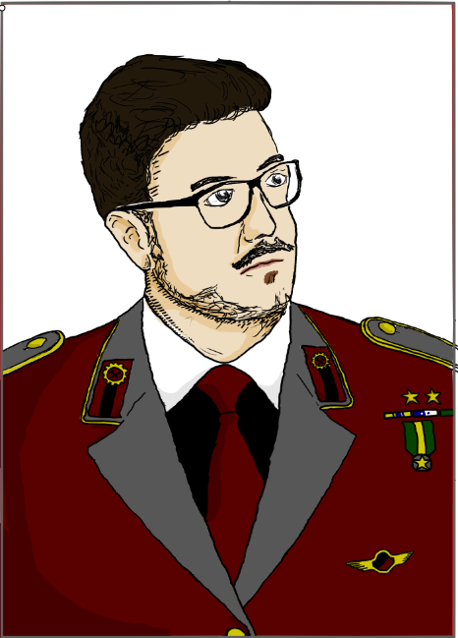

Art belongs to @OpossumMan Description to I, @Revlise